Natural Language Processing Lab 3

**Part A. Generative Grammars**

**1.**

1. I want a flight

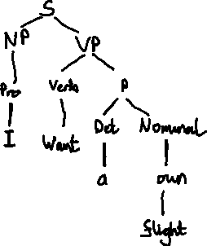

2. I want a morning flight

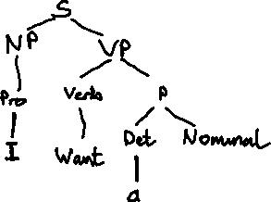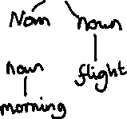

3. I want a flight in the morning

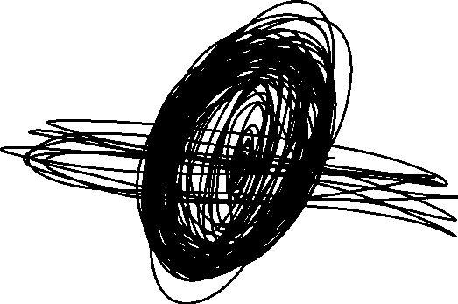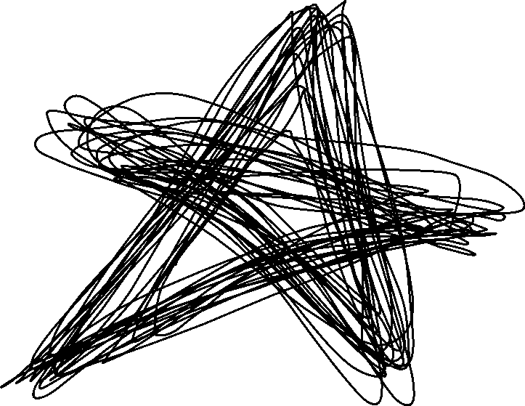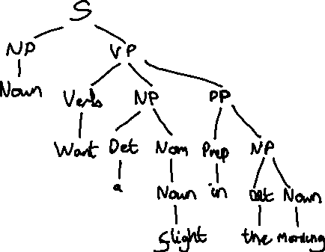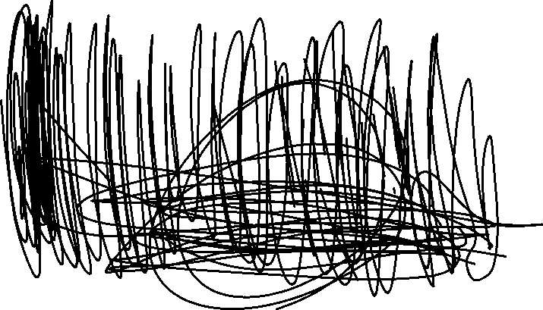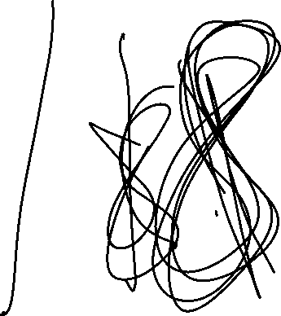

**2.**

1. I want a flight in the morning from Baltimore

VP -> Verb NP PP PP

2. I want a flight from Baltimore to Los Angeles

VP -> Verb NP PP PP

3. I need a trip in the morning from Baltimore to Los Angeles

VP -> Verb NP PP PP PP

**3.**

1. Do you have a flight in the morning?



2. What flights do you have?



**4.**

The two needed new rules are:  
NP -> Adj Noun

Adj -> Adj Adj

1. direct flight



2. first direct flight



3. first non-stop direct flight



**5.**

NP -> Proper-Noun possessiveMorpheme

Lexicon

possessiveMorpheme -> ‘s

**Part B. Logical Grammars**

**1.**

1. John



2. John and Mary

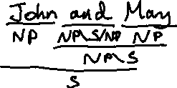

3. John slept

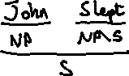

4. John slept and snored

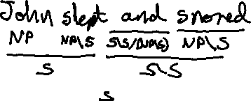

5. John and Mary slept

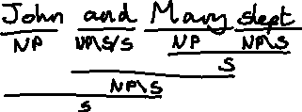

6. John and Mary slept and snored

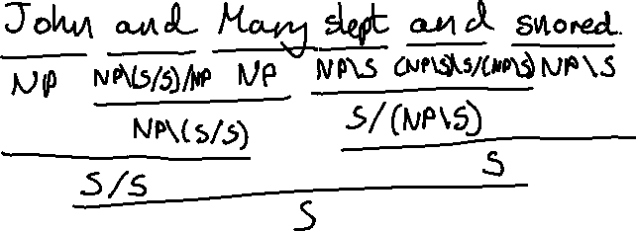

7. John ate pizza

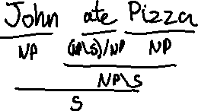

8. John and Mary ate Pizza and Pasta

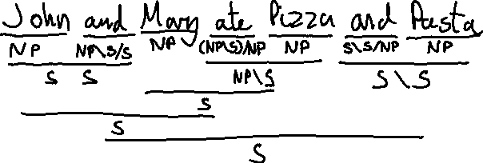

**2.**

Big = S/X

1. Big John

X = NP

Big = S/NP

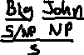

2. Big John slept

X = S

Big = S/S

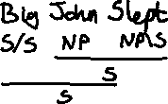

3.Big John ate Pizza

X = S

Big = S/S

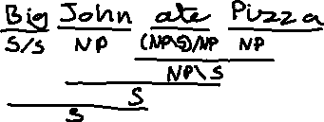

4. Big John and Mary

X = S

Big = S/S

And = NP\S/NP

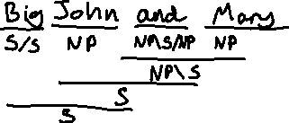

**3.**

Big | Who Q/S

1. Did John sleep

2.

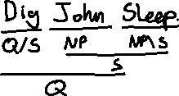

2. Did John eat Pizza

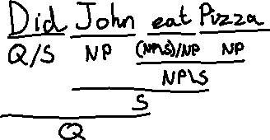

Natural Language Processing Lab 4

Part A. Dependency Grammars

**1.**

1. I want a flight

2. I want a morning flight

3. I want a flight in the morning



4. I want a flight in the morning from Boston

**2.**

1. I want from you a flight in the morning

2. I want from Boston a flight in the morning

3. I want a flight in morning the



**3.**

1. John and Mary booked the first direct flight and slept

**Part B. CKY Parsing with Context Free Grammars.**

1. Chompsky Normal form Production Rules

|  |
| --- |
| Production Rules |
| S → VP X1  X1 → NP PP  S → VP NP  VP → *Verb*  PP → *Prep* NP  PP → PP PP  NP → *Det* *Noun*  NP → NP PP  NP → *Det* Y1  Y1 → AP *Noun*  AP → *Adj* AP  AP → *Adj* |

1. Parse ‘Take the big yellow banana’ using the new production rules

|  |  |  |  |  |
| --- | --- | --- | --- | --- |
| **Take** | **the** | **big** | **yellow** | **banana** |
| **VP,Verb**  **[0,1]** | **[0,2]** | **[0,3]** | **[0,4]** | **S**  **[0,5]** |
|  | **Det**  **[1,2]** | **[1,3]** | **[1,4]** | **NP**  **[1,5]** |
|  |  | **AP,Adj**  **[2,3]** | **AP**  **[2,4]** | **Y1**  **[2,5]** |
|  |  |  | **AP,Adj**  **[3,4]** | **[3,5]** |
|  |  |  |  | **Noun**  **[4,5]** |

|  |
| --- |
| Production Rules |
| S → VP X1  X1 → NP PP  S → VP NP  VP → *Verb*  PP → *Prep* NP  PP → PP PP  NP → *Det* *Noun*  NP → NP PP  NP → *Det* Y1  Y1 → AP *Noun*  AP → *Adj* AP  AP → *Adj* |

There is only one parse for this sentence.

**3.**

|  |  |  |  |  |  |  |  |  |  |
| --- | --- | --- | --- | --- | --- | --- | --- | --- | --- |
| **Put** | **The** | | **Ball** | **Behind** | **The** | **Apple** | **In** | **the** | **Hat** |
| **VP,Verb**  **[0,1]** | **[0,2]** | | **S**  **[0,3]** | **[0,4]** | **[0,5]** | **S**  **[0,6]** | **[0,7]** | **[0,8]** | **S,X1**  **[0,9]** |
|  | **Det**  **[1,2]** | | **NP**  **[1,3]** | **[1,4]** | **[1,5]** | **NP,X1**  **[1,6]** | **[1,7]** | **[1,8]** | **NP,NP,X1**  **[1,9]** |
|  |  | | **Noun**  **[2,3]** | **[2,4]** | **[2,5]** | **[2,6]** | **[2,7]** | **[2,8]** | **[2,9]** |
|  | | |  | **Prep**  **[3,4]** | **[3,5]** | **PP**  **[3,6]** | **[3,7]** | **[3,8]** | **PP,PP**  **[3,9]** |
|  |  | **Det**  **[4,5]** | **NP**  **[4,6]** | **[4,7]** | **[4,8]** | **NP**  **[4,9]** |
|  |  |  | **Noun**  **[5,6]** | **[5,7]** | **[5,8]** | **[5,9]** |
|  |  |  |  | **Prep**  **[6,7]** | **[6,8]** | **PP**  **[6,9]** |
|  |  |  |  |  | **Det**  **[7,8]** | **NP**  **[7,9]** |
|  |  |  |  |  |  | **Noun**  **[8,9]** |
| Production Rules | |
| S → VP X1  X1 → NP PP  S → VP NP  VP → *Verb*  PP → *Prep* NP  PP → PP PP  NP → *Det* *Noun*  NP → NP PP  NP → *Det* Y1  Y1 → AP *Noun*  AP → *Adj* AP  AP → *Adj* | |

You can perform 6 full parses from the sentence.

Put the ball  
Put the apple  
Put the hat  
Put the ball behind the apple  
Put the ball in the hat  
Put the ball behind the apple in the hat.